COMPARATIVE ANALYSIS OF MACHINE LEARNING ALGORITHMS FOR FRAUD DETECTION IN HEALTHCARE INSURANCE.

BY

OGUNBIYI, IBUKUNOLUWA TOYOSI
(RUN/CMP/20/9518)

A PROJECT SUBMITTED TO
THE DEPARTMENT OF COMPUTER SCIENCE,
FACULTY OF NATURAL SCIENCES,
REDEEMERS UNIVERSITY, EDE, OSUN STATE, NIGERIA

IN PARTIAL FULFILMENT OF THE REQUIREMENTS FOR THE AWARD OF THE DEGREE OF BACHELOR OF SCIENCE(BSc.)IN COMPUTER SCIENCE

JULY,2024

DECLARATION
I, Ogunbiyi, Ibukunoluwa Toyosi (RUN/CMP/20/9518), hereby declare that this project was carried out by me in the Department of Computer Science, Faculty of Natural Sciences, Redeemer's University, Ede, Osun State, Nigeria. To the best of my knowledge, this work has not been presented elsewhere for the award of a degree or any other purpose.

Ogunbiyi Ibukunoluwa …………………………………
Student Signature & Date

CERTIFICATION
We, the undersigned,hereby certify that this project was completed by Ogunbiyi Ibukunoluwa Toyosi (RUN/CMP/20/9518) in the Department of Computer Sciences, Faculty of Natural Science, Redeemer's University, Ede, Osun State, Nigeria. This work has not been presented anywhere, to our knowledge, to receive a degree or for any other reason.

Dr. (Mrs.) B.O Oguntunde
Supervisor Signature & Date

Dr. (Mrs.) B.O Oguntunde
Head of Department Signature & Date

Prof. S. O. Akinola
External Supervisor Signature & Date

DEDICATION
This project is dedicated to the Almighty God For the Grace, Wisdom, Knowledge and Strength given to me throughout this program. This project is also dedicated to my family and friends, who supported me all the way; I say a very big thank you, and God bless you all.

ACKNOWLEDGEMENT
My deepest gratitude is to God, who has been providing for me each step on the way and making this project a success.
I would love to express my sincere appreciation to my project supervisor, Dr.(Mrs.) B. O. Oguntunde, for her motherly love and corrections each time there was an error in my project, A very big thank you to Mrs A.O Adio for all her support and care and to all my lecturers that has instilled good knowledge in me. I would love to appreciate my family,my sister and parents, Mr and Mrs Ogunbiyi for sending me to this great citadel of learning and being my greatest support since the beginning of this project. To all my colleagues and my friends starting with Akindeinde Ayotunde, Oluwole Eniola, Adesanya Ayomide, Ladeji Farayioluwa, Iruene Siki,Oyebode Jeremiah,OyefiadeAdedamola, Ayomide David and a lot of more, Thank you for all your contributions and support to make this project a success.
God bless you all.

TABLE OF CONTENT
Content Page

TITLE PAGE i
DECLARATION ii
CERTIFICATION iii
DEDICATION iv
ACKNOWLEDGEMENT v
TABLE OF CONTENT vi
LIST OF TABLES viii
LIST OF FIGURE ix
ABSTRACT xi
CHAPTER ONE INTRODUCTION 1
1.1 Background of the Study 1
1.2 Problem Statement 3
1.3 Aim and Objectives of the Study 3
1.4 Overview of Methodology 3
1.5 Scope of the study 4
1.6 Significance of the Study 4
1.7 Definition of Terms 4
1.8 Organization of project 6
CHAPTER TWO REVIEW OF LITERATURE 7
2.0 Introduction 7
2.1 Fraud Detection in Healthcare 7
2.2 Types of Healthcare Fraud 8
2.3 Machine Learning 8
2.3.1 Machine Learning Models 9
2.3.2 Supervised Learning 10
2.3.3 Supervised methods 10
2.3.4 Unsupervised Learning 16
2.3.5 Reinforcement Learning 17
2.4 Related Works 17
CHAPTER THREE METHODOLOGY 27
3.0 Introduction 27
3.1 Data Collection 27
3.2 Datasets 27
3.3 Architecture of the model 28
3.4 Data Preprocessing 30
3.4.1 Data Cleaning 30
3.4.2 Data Integration 31
3.4.3 Data Reduction 32
3.4.4 Data Transformation 32
3.5 Feature Engineering 33
3.6 Confusion Metrics 34
3.7 Performance Metric 35
CHAPTER FOUR SYSTEM IMPLEMENTATION AND 37
RESULT DISCUSSIONS

4.0 Introduction 37
4.1 Software Requirement 37
4.1.1 Libraries 38
4.2 Exploratory Data Analysis 38
4.2.1 Dataset Preprocessing and Analysis 38
4.3 Data cleaning 42
4.4 Feature Engineering 43
4.5 Handling Class Imbalance 44
4.6 Algorithm Implementation 45
4.6.1 Decision Tree Classifier 45
4.6.2 Logistic Regression Model 46
4.6.3 Random Forest Model 47
4.6.4 AdaBoost Model 48
4.7 System Evaluation 50
4.7.1 Evaluation of Decision Tree Classifier 50
4.7.2 Evaluation of Logistic Regression Model 51
4.7.3 Evaluation of Random Forest Model 52
4.7.4 Evaluation of the Adaboost Model 53
CHAPTER FIVE SUMMARY, CONCLUSION AND 56
RECOMMENDATIONS
5.0 Introduction 56
5.1 Summary 56
5.2 Conclusion 57
5.3 Limitations 57
5.4 Recommendations and Future Works 57
REFERENCES 58
APPENDIX SOURCE CODE OF THE PROJECT 63

LIST OF TABLES
Table Page
Table 2.1 Summary of related works 22
Table 4.1: Summary of Tools, Libraries and Programming Environment Used 37
Table 4.2: Summary of the results of the Decision tree classifier 50
Table 4.3: Summary of the result of the logistic regression model 51
Table 4.4: Summary of the result of the random forest model 52
Table 4.5: Summary of the result of the Adaboost model 54
Table 4.6: Comparison of models 55

LIST OF FIGURE
Figure Page
Figure 2.1 Architecture of Neural Network 12
Figure 3.1: Architecture of the model 29
Figure 3.2. Data preprocessing cycle 29
Figure 3.3: Confusion Matrix 33
Figure 4.1 Libraries implemented in this Dataset 37
Figure 4.2 The file saved in a specific file path 38
Figure 4.3 Description of the Dataset Head 39
Figure 4.4 Merging patient data, beneficiary data and train data 40
Figure 4.5 Data cleaning has been implemented. 41
Figure 4.6 Attending Physician attending to patients 42
Figure 4.7: Final Dataset 42
Figure 4.8: Applying SMOTE Technique 43
Figure 4.9: Splitting the dataset and training the Decision Tree Classifier 44
Figure 4.10: Evaluation of the Decision Tree Classifier Model 45
Figure 4.11: Splitting and Training the Logistic Regression Model 45
Figure 4.12: Evaluation of Logistic Regression Model 46
Figure 4.13: Splitting and Training the Random Forest Model 47
Figure 4.14: Evaluation of Radom Forest Model 47
Figure 4.15: Splitting and Training the AdaBoost Model 48
Figure 4.16: Evaluation of AdaBoost Model 48
Figure 4.17: Confusion Matrix of Decision Tree classifier model 50
Figure 4.18: Confusion Matrix of the Logistic Regression Model 51
Figure 4.19: Confusion Matrix of the Random Forest model 52
Figure 4.20: Confusion Matrix of the AdaBoost model 53

ABSTRACT

Healthcare fraud is intentionally submitting false claims or producing misinterpretation of facts to obtain entitlement payments. Thus, it wastes healthcare financial resources and increases healthcare costs.Healthcare insurance fraud are often committed by either the healthcare providers, the insurance companies or consumers. Fraud in healthcare insurance is a significant issue leading to substantial loss of money.
The methodology of this research is to detect fraudulent activities in the healthcare insurance industries using machine learning algorithms such as Decision Tree classifier, Logistic Regression Algorithm, Random Forest Classifier and Ada-boost algorithm.The performance of the models were evaluated based on the Accuracy, F1-Score, Recall, and Precision. The results that were generated based on the Accuracy of the Random Forest , Decision Tree, Logistic Regression, and Adaboost were 95.3%, 92%, 83%, and 91.13% respectively.The comparative results shows that the Random Forest performs better that the other machine learning models.
The Output of this study can be used to detect fraudulent activities in the healthcare industry and minimize the rate at which it occurs.

Keywords: Insurance, Fraud Detection, Machine Learning, Healthcare Fraud,Datasets.

CHAPTER ONE

INTRODUCTION

1.1 Background of the Study
Fraud is the "deception or intentional misrepresentation that a person or entity makes knowing that the misrepresentation could result in an unauthorized benefit for the person, entity or another part"(NHCAA,2018). With the average life span increase, the healthcare system has grown in importance and cost. Fraudulent use of health insurance strains available funds and raises the cost of healthcare (Chen et al., 2020).
Health Insurance Fraud poses a significant challenge, costing billions of Naira annually and undermining the sustainability of healthcare systems. Manufacturers, hospitals, pharmacies, healthcare providers, distributors, and payers are most affected by healthcare fraud (Mackey et al.,2020).
Healthcare fraud includes billing for services undelivered or unnecessary, misrepresentation, or willful omission that are essential in determining benefits to be paid, rebilling, readmission, upcoding, unbundling, kickbacks practising, and unjustified distribution of healthcare services and medications (Nicholas et al., 2020).
Due to the massive increase in the population, the need for a high-quality medical system and healthcare insurance has become increasingly important (Bauder & Khoshgoftaar, 2018).
To improve medical-related development, the government has begun using electronic data to record various information and gradually popularizing extensive medical data development (Liang et al., 2019). Medical information systems store a large amount of medical data, including patient data, medical records, and medical insurance records (Tanwar et al., 2020; Dash et al., 2019). Therefore, the country can follow this data to establish a more complete medical system. Fraud, waste, and abuse of healthcare insurance will seriously impact the medical insurance system (Mackey et al., 2020). The research found that up to 46% of healthcare practitioners not covered by insurance programs endanger patients' safety (Nicholas et al., 2020).
However, because medical services are relatively easy to obtain, healthcare insurance fraud and misuse have emerged one after another, causing the country's medical expenditure to rise year by year.
According to scholars, there are various fraud detection methods; for instance, one depends on decoding the data into five stages. The first three stages only investigate claims, providers, and services, while the fourth stage estimates the risk size. The last step includes a decision-making mechanism to declare or not to report the existence of Fraud (Thaifur et al., 2021).
Nowadays, people rely on health insurance to share the high healthcare costs. Health insurance can be sponsored by the government or managed by the private sector.
In healthcare fraud detection, There are three entities involved they include Service providers (which include doctors, hospitals, and laboratories), Insurance subscribers( which include patients and patients' employers), and insurance carriers(which include governmental health departments and private insurance companies).

1.2 Problem Statement
Health insurance is a deal/contract that requires an insurer to pay some or all of an individual healthcare costs in exchange for a premium. Healthcare Insurance mainly covers the bills of medical, surgical, and drug prescription expenses incurred by the insured. Fraud in healthcare insurance is a significant issue leading to substantial loss of money. This project aims to detect fraudulent health insurance claims and save considerable money from Fraud.

1.3 Aim and Objectives of the Study
This study compares four machine learning models for detecting Fraud in healthcare insurance Industries.
The specific objectives to achieve this aim are to:
i.obtain datasets from Kaggle.
ii.train four machine learning algorithms for the detection of fraud.
iii.test the machine learning models
iv. compare the performance of the four machine learning models.

1.4 Overview of Methodology
The methods that will be applied in the accomplishment of this project are as follows:
i.The datasets were obtained from the available Kaggle Website,
ii. Data cleaning and preprocessing,
ii.Train four machine models machine learning algorithms including Decision Tree classifier, Logistic Regression Algorithm, Random Forest Classifier and Ada-boost algorithm using Python programming language.
iii. Test the machine learning models,
iv.The evaluation is based on metrics such as accuracy,f1-score, recall score, and precision score.

1.5 Scope of the study
Due to security and privacy reasons, access to healthcare insurance data can be difficult, therefore a few authentic datasets have been created to use them to detect Fraud.
The scope of the study is thereby restricted to the healthcare insurance system in Nigeria.

1.6 Significance of the Study
The principal importance of the study is to detect and possibly prevent Fraud in healthcare. There will be a reduction in the number of victims affected by Fraud, and the best practices to detect Fraud in the health industry will be recommended.

1.7 Definition of Terms
Insurance: Insurance is a contract between individuals and companies to provide financial protection against potential losses. Insurance serves as a risk management tool designed to protect against the potential of unpredictable losses.

Health Insurance: Health Insurance is a specialized form of coverage that safeguards individuals against the financial risks associated with medical expenses. This includes insurance for losses from accidents, disabilities, and accidental deaths.(Kulkarni & Kasulkar,2021).
Fraud: Fraud is an intentional deception or misleading of another person to deprive them of something valuable such as money, property, or a legal right.
Fraud Detection: Fraud detection refers to the identifying and preventing fraudulent activities within a system or Organization.
Datasets: A collection of instances used for constructing or evaluating the performance of a machine-learning model.

1.8 Organization of project
The project consists of five(5) chapters. The first chapter (Chapter One) is the introduction, which gives an overview of the subject, including the background on the objectives and problem statement. The second chapter (Chapter Two) is about the literature review, which describes previous works, techniques, and algorithms used to detect fraudulent claims in healthcare in detail. The third chapter (Chapter Three) is about the methodology, which explains the model established and the theoretical approaches used for the machine learning algorithm. The fourth chapter (Chapter Four) is about the implementation and result. The fifth chapter (Chapter Five) draws the conclusion, summary, limitation, and recommendations.

CHAPTER TWO

REVIEW OF LITERATURE

2.0 Introduction
In this chapter, there will be a comprehensive review of relevant literature on healthcare insurance fraud detection. The literature review is organized into sections covering healthcare fraud overview, machine learning in fraud detection, and related works on fraud detection in healthcare insurance.

2.1 Fraud Detection in Healthcare
Fraud is any deceitful action providing a person with an illegal or unfair advantage or denying certain rights to a victim. Healthcare fraud involves intentionally manipulating the healthcare system for personal gains and can be committed by patients, providers, or an organization. Healthcare fraud remains a critical issue globally, impacting both public and private healthcare systems. Fraudulent activities in healthcare involve various forms of deception, including billing for services not rendered, upcoding, kickbacks, and identity theft. The consequences of healthcare fraud are significant, leading to increased costs, compromised patient care, and reduced trust in the healthcare system (Mackey et al., 2020).

2.2 Types of Healthcare Fraud
The following can be classified as types of Fraud:
Billing fraud: This is a type of Fraud that involves submitting false or inflated bills to insurance companies or government programs like Medicare. Examples include billing for services not rendered, up-coding procedures, or duplicating bills for the same services.
Patient fraud: This is a type of Fraud that involves patients deceiving the system to obtain unnecessary services or medications. Examples include claiming to have a condition they don't have or using someone else insurance card.
Provider fraud: This type of Fraud involves healthcare professionals engaging in fraudulent activities for financial gain. Examples include receiving payment for referring patients to unnecessary services.
Prescription drug fraud: This is a type of Fraud that involves illegal obtaining or using prescription drugs. Examples include forging prescriptions and selling prescription drugs on the black market.

2.3 Machine Learning
Machine learning algorithm is a mathematical technique used to identify patterns within a dataset; these algorithms are derived from fields such as statistics, calculus, and linear algebra. With these algorithms, fraud detection can be achieved mainly through statistics and mathematical learning methods, which can be used to combat Fraud. These methods are classified under data mining. Data mining is discovering meaningful patterns, new correlations, and trends by sifting through large amounts of data stored in repositories using pattern recognition techniques(Daciuk &Jou.,2010).
The emergence of machine learning (ML) has revolutionized fraud detection by enabling automated analysis of large datasets to identify patterns indicative of Fraud. Common machine-learning techniques in fraud detection include Decision Trees, Logistic Regression, Random Forest, Support Vector Machines, and Neural Networks (Chen et al., 2020).

2.3.1 Machine Learning Models

Machine Learning Algorithms analyze data to make predictions or decisions without being explicitly programmed. These models learn by identifying patterns in data, adjusting their parameters accordingly, and improving their performance over time. Machine learning models are applied in various fields, such as finance, healthcare, marketing, and autonomous vehicles.
Machine learning models can be classified into three(3) main types, including Supervised Learning, Unsupervised Learning, and Reinforcement Learning.

2.3.2 Supervised Learning

This is a type of machine learning where the Algorithm learns from labelled data. This data consists of input features and corresponding outputs or labels, allowing the model to understand the relationship between them to help make accurate predictions on new, unseen data.
The supervised Learning model is further subdivided into Classification and Regression.

Classification: This uses an algorithm to accurately assign test data into specific categories and classes based on one or more variables. A program acquires knowledge from the provided datasets or observations and subsequently categorizes new observations into various classes or groups, such as "Yes" or "No," or "0" and "1." Some widely used classification algorithms include linear classifiers, support vector machines, decision trees, k-nearest neighbours, and random forests.

Regression: This uses an algorithm to understand the relationship between dependent and independent variables.it is a technique used to predict continuous values. It is commonly used to make projections, such as predicting sales revenue for a specific business. Common algorithms are Linear Regression, Logistic Regression, and polynomial Regression.

2.3.3 Supervised methods

Neural Networks: These are often called Artificial Neural Networks, primarily leveraged for deep learning algorithms. It is a model inspired by neuronal Organization found in the biological neural networks in animal brains. Neural Networks process training data by mimicking the interconnectivity of the human brain through layers of nodes.
It develops an adaptive system that enables computers to learn from their errors and continually enhance their performance. These nodes, called artificial neurons, process information and learn through backpropagation. Each neuron receives input from other neurons, applies a mathematical function to transform feedback, and sends the output to other neurons (Goodfellow et al., 2016).
Neurons are structured in layers, which include the input layer, hidden layer, and output layer, as presented in Figure 2.1. The input layer receives data, The hidden layer processes and transforms the information, and the output layer produces the final prediction or classification. (Goodfellow et al., 2016)
There are several different kinds of neural networks, including recurrent neural networks (RNN), feedforward neural networks (FNN), convolutional neural networks (CNN), and generative adversarial networks.(Citko& Sienko.,2022).

One of the greatest strengths of neural networks is their exceptionally high accuracy in challenging tasks such as machine translation, natural language processing, and image recognition,especially when trained on huge datasets (He et al.,2016),The method helps detect Fraud in healthcare due to its enormous variable and quantity of data( Ma et al.,2018).
A significant disadvantage of Neural networks is Overfitting, which is a behaviour that occurs when the model gives accurate predictions for training data but not the new data. Healthcare data is principally sensitive to overfitting because there are more legitimate cases than fraudulent ones. An excellent way to solve the overfitting problem is to add weighted delay to the error function for training neural networks. Other disadvantages may include a Lack of transparency, data dependency, etc.
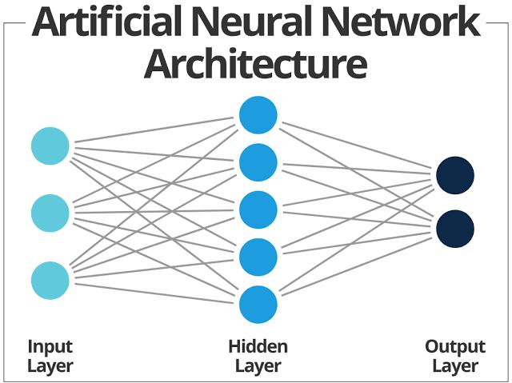

Figure 2.1 Architecture of Neural Network(source: Gurneet, 2023)

Decision Tree
This is another machine-learning technique that is used for classification and regression tasks. Decision trees break down datasets into smaller and smaller subsets based on different features, resulting in a tree-like decision structure. It consists of root, branches, internal, and leaf nodes. Decision nodes are used to make choices with multiple possible outcomes, while leaf nodes represent the final results of those choices and do not lead to any additional branches. A Decision tree asks a question, and based on the answer (Yes/No), it further splits the tree into sub-trees whereby The decisions or the test are performed based on features of the given dataset. Decision trees map formation by several classifiers following politics, such as minimizing false positives(reducing the cost of unnecessary fraud investigations), minimizing false negatives(maximizing fraud detection ability), and achieving a trade-off between false positives and false negatives.
A significant advantage of the decision tree is that it is easy to interpret, making it easy to see which attributes are more important; it requires little to no data preparation and is more flexible than other algorithms. Decision Tree also makes use of adaptive boosting to reduce misclassification errors. The various classifiers are constructed sequentially, with each focused on those training cases that have been misclassified by previous classifiers(Ngai et al.,2011)

Decision Tree Terminologies
Root Node
The root node represents the entire dataset, which is then divided into two or more homogeneous subsets.

Leaf Node
Leaf nodes serve as the final output nodes, indicating that no further segmentation of the tree is possible after reaching a leaf node.
Splitting
Splitting involves dividing a decision node or root node into sub-nodes based on specified conditions.
Branch/Subtree
A branch or subtree is created by the process of splitting the main tree.

Pruning: Pruning is the process of removing the unwanted branches from the tree.

Parent/Child node:Other nodes are referred to as child nodes, while the root node of the tree is called the parent node.

Entropy:. It describes the data's unpredictability. Entropy can be calculated as:

Entropy(s)= -P(yes)log2 P(yes)- P(no) log2 P(no)

Where,
S= Total number of samples in the dataset
P(yes)= probability of yes, which are fraudulent cases
P(no)= probability of no, which are non-fraudulent cases

viii. Gini Index: This is a measure of impurity or purity used while creating a decision tree in the CART(Classification and Regression Tree) algorithm. The Gini index can be calculated using the below formula:

Gini Index= 1- ∑jPj2

Decision Trees are an excellent approach to detecting Fraud in healthcare because of their simplicity in interpreting the results, ability to generate rules from the trees, and ability to handle missing values.

Support Vector Machine
This learning technique is used to solve binary classification problems, which require classifying the elements of datasets into two groups. It is a method in machine learning that analyses data to recognize patterns (Liu et al.,2002).
They aim to find the optimal hyperplane that best separates the data into different classes while maximizing the margin between classes.A hyperplane is a decision boundary that divides data points into distinct classes.
SVM handles non-linearly separable data by mapping the input features into a higher-dimensional space using a kernel function. Some common kernels include Linear kernels, polynomial kernels, and Radial Basis Function Kernels(RBF). SVMs help analyze complex data that a simple straight line can't separate.

Logistic Regression
This learning technique is a statistical method used for binary classification. This technique accomplishes tasks by predicting the probability of an outcome, event, or observation to determine the probability of Yes/No, Spam/Not. Logistic regression assesses the relationship between dependent and independent variables by estimating probabilities using logistic functions.
Logistic Regression uses a more complex function than Linear Regression. This cost function is the 'Sigmoid Function', also called the 'Logistic Function'.
The sigmoid function is a function that maps predicted absolute values to probabilities between 0 and 1. The sigmoid function formula is calculated as

Random Forest
According to Breiman and Cutler (2001), random forests are made up of a combination of tree predictors where each tree in the forest is dependent on the value of a random vector that is sampled randomly and has the same distribution for all the trees in the forest.This approach, which is a machine learning technique, mixes several models to improve performance overall, especially when dealing with regression and classification problems.This method constructs numerous decision trees during the training phase and provides the mean prediction of the individual trees as the final output. Random forests are renowned for their resilience and capacity to manage high-dimensional data and extensive datasets effectively.

Ada-Boost
AdaBoost is a short form of adaptive boosting that combines multiple weak classifiers to create a strong classifier (Schapire,2013). it is a sequential process that involves training a weak model on a dataset, building subsequent models based on the errors of the previous ones and iterating them until a highly accurate classifier is achieved. Ada boost is an ensemble method that mainly focuses on classification tasks.

2.3.4 Unsupervised Learning
An unsupervised learning model is a machine learning algorithm in which the system tries to find patterns in datasets without prior knowledge about the data's structure, i.e. it works on unlabeled datasets. The model independently discovers groupings or representations within the data. The tasks carried out by this Algorithm include clustering. These models are often used for exploratory data analysis, preprocessing, and feature extraction. Some models under this Algorithm include K-means Clustering, Hierarchical clustering, anomaly detection, principle component analysis, etc.

2.3.5 Reinforcement Learning
This is a machine learning technique in which an agent learns to make decisions through interactions with its environment.This type of Algorithm trains software to make decisions to achieve the most optimal results, lets the agent take actions, and gets the environment to give feedback based on those actions in the form of penalties or rewards. This feedback or response from the environment helps the agent adjust its strategy and gradually improves its decision-making abilities.The agent learns by experimenting through trial and error, trying out various actions and observing the outcomes. This machine learning algorithm can be utilized in areas such as gaming, finance, and autonomous systems.

2.4 Related Works
Johnson and Nagarur(2015) a novel multistage approach for insurance companies to identify fraudulent activities perpetrated by healthcare providers and patients. These methodologies were divided into Six(6) stages. The first three(3) stages aim to detect abnormalities among providers, services, and claims amounts. In contrast, the fourth stage integrates the information obtained in the previous stages into an overall risk measure. Stage five(5) used a decision tree-based method to compute risk threshold values, and stage six(6) to compare whether the claims of data gathered from a private insurance company were fraudulent or Non-Fraudulent.
Furthermore, There was a comparison between the Neural Network model and the Multistage Methodology. The result shows that 27% of these claims from the dataset were considered fraudulent. It was also observed that the accuracy rate of these other methodologies was 86%, which outperformed the neural network approach. Due to multiple methodologies, the chances of having false positives were high.

Saba et al. (2017) proposed an approach for detecting fraudulent health insurance claims by identifying correlations between some attributes on the claims document. They applied the evolving clustering method(ECM), an unsupervised data mining technique, a Support Machine Vector, a supervised machine learning model, and an apriori algorithm to find the frequently correlated attribute from the given data. Due to limited datasets and resources, they could only identify the associated attribute and generate an association but could not make it to the classification phase.

Lavanya et al. (2021) designed a model to compare the performance of predictive analysis for healthcare fraud detection using various machine learning algorithms such as Logistic Regression, Random Forest, Support Vector Machine, Ada boost, Multi-layer Perceptron and Gradient Boost. The results show that the Multi-layer perceptron neural network approach outperforms other models' accuracy, sensitivity, specificity and F-measures.

Debener et al. (2022) implemented Isolation Forest and Extreme Gradient Boost(XGB), unsupervised machine learning algorithms and a few labelled fraud cases to detect insurance fraud. The result of both Isolation Forest and XGB is that they are fast, convenient, and effective methods to detect Fraud. Still, due to limited resources, using both unsupervised and supervised approaches has yet to be recognized as an existing mechanism.

Laiqa et al. (2022). A comparative analysis was conducted on a model to predict and detect insurance fraud using the following machine learning algorithms: Support Vector Machine, Random Forest, Decision Tree, Ada boost, K-Nearest Neighbour, Logistic Regression, Naive Bayes and Multi-layer Perceptron. The result shows that Decision Tree has the highest accuracy of 79%, followed by Ada Boost, which has an accuracy of 78%.

Veena et al. (2023) proposed addressing fraud issues in health insurance claims using machine learning algorithms: Logistic Regression, Random Forest, Decision Tree and Naive Bayes, which would be applied to detect Fraud in the healthcare industry. The result shows that Decision Tree had the highest accuracy with 97.03%, but they were challenged with an incomplete dataset that might have impacted the performance.

Nabrawi and Alanazi (2023) built a model to detect Fraud in healthcare claims in Saudi Arabia. The applied models were random forest, logistic regression, and artificial neural networks, whereby they implemented the SMOTE (Synthetic Minority Oversampling Technique) to balance the dataset. The sample size of the data collected from three healthcare providers accumulated to 396 in total. After evaluating the datasets with the models available, Random Forest had an accuracy of 98.21%, leading the other models. The result shows 64% positive fraud cases and 36% negative cases from the dataset. The non-availability of a larger sample size and limited numbers of variables could not help the researchers achieve good accuracy in the fraud detection model.

Nalluri et al. (2023) built prediction models to discover the essential factors of medical Fraud and find the optimal machine-learning method. The study utilized two unpublished datasets and employed four machine learning techniques: Support Vector Machine (SVM), Decision Tree (DT), Random Forest (RF), and Multi-layer Perceptron (MLP) to identify the most effective method for detecting medical fraud. The result shows that MLP had an overall accuracy of 77.1% and was also more significant compared to the other models, but the problem with the result is that it had slow training time.

Agarwal (2023) presented an intelligent machine-learning approach for fraud detection in medical claims insurance to enhance fraud detection accuracy and efficiency. The applied model used in this research is K-means Clustering, an unsupervised machine learning algorithm used to identify natural clusters of medical claims and patterns based on their features, helping distinguish legitimate and potentially fraudulent claims. The result of the research showed that K-means achieved an accuracy of 0.88, thereby minimizing false positives compared to the presented baseline models. This research is limited by the quality and representation of the dataset used for training.

Naga et al. (2023) conducted a comparative analysis using a machine learning algorithm to identify fraudulent and non-fraudulent healthcare claims. Specifically, they analyzed behaviours in the Center for Medicaid and medicare services(CMS) data. The machine learning algorithms used included Random Forest (RF), Support Vector Machine(SVM), Logistic Regression(LR), and Artificial Neural Neural (ANN). The result indicated that SVM had superior accuracy in identifying fraudulent and non-fraudulent claims compared to other algorithms.

Table 2.1 Summary of related works
S/N | AUTHOR/YEAR | TOPIC | METHODOLOGY | RESULTS
1 | Johnson &Nagarur (2015) | A multi-stage methodology for detecting health insurance claim fraud | involves the use of video profiling, screening medical demographics, risk qualification, determining risk thresholds, and comparing the assessed risk against threshold values. Additionally, a neural network approach is employed to identify fraudulent activities. | All the methodology gives an accuracy of 86% and the multi stage algorithm outperformed the neural network approach in terms of accuracy
2 | Saba et al (2017) | Framework for identification of fraudulent health Insurance claims using Association Rule Mining | The use of Evolving Clustering Method(ECM) and Support Vector Machine(SVM) were used to identify fraudulent claims in healthcare | Identification of associated attributes,pre processing steps on collected claims documents and generation of association rules has been successful
3 | Lavanya et al (2021) | Machine learning based approaches for healthcare fraud detection: A comparative analysis | Use of Multi-layer perceptron algorithm,Logistic Regression,Random forest,Support vector machine,Ada boost classifier and gradient boost to compare what model is best used to detect Fraud. | The Multi-layer perceptron algorithm outperformed well in terms of accuracy,sensitivity ,specificity and F-measure compared to the other models
4 | Debener et al (2022) | Detecting insurance fraud using supervised and unsupervised machine learning | The models used were Isolation forest and Extreme Gradient boost(XGB) to successfully detect Fraud. | The study recommends isolation forest to be a convenient and effective and XGBoost to be fast and effective methods to be used to detect Fraud
5 | Laiqa et al (2022) | Prediction of insurance fraud detection using machine learning algorithms | Use of Machine Learning Algorithms such as Support Vector Machine(SVM),Random Forest(RF),Decision Tree(DT),Ada boost,K-Nearest Neighbour(KNN),Linear Regression(LR),Naive Bayes(NB) and Multi-layer Perceptron(MLP). | It was concluded that Decision tree(DT) gives the highest accuracy of 79% as compared to other techniques and Ada boost shows a 78% accuracy closest to Decision tree(DT).
6 | Veena et al(2023) | Predicting Health insurance claim fraud using supervised machine learning techniques | The use of Logistic Regression,Decision Tree,Random Forest and Naive Bayes were the algorithms applied to detect fraudulent claims | Decision Tree classifier had the highest accuracy of 97.03% compared to the other models
7 | Nabrawi et al(2023) | Fraud detection in healthcare insurance claims using machine learning | The use of Random forest(RF),Logistic Regression(LR) and Artificial Neural Network(ANN) were used to detect health care insurance fraud. | The accuracy of the models were read as Random forest to be 98.21% accurate,Logistic Regression to be 80.36% accurate and artificial neural network to be 94.64% accurate.According to the results, Random forest appears to be the most performing and promising evaluation metrics compared to the other models
8 | Nalluri et al (2023) | Building prediction models and discovering important factors of health insurance fraud using machine learning methods | 2 unpublished datasets consisting of the patient's insurance claims record and other providers supplements and 4 machine learning algorithms which are Support vector machine(SVM),Random forest(RF),Decision tree(DT) and Multi-layer perceptron(MLP) that is used to find the best machine learning method that can effective for detecting Fraud | The overall accuracy considers MLP with (77.17%) to be slightly better than DT with (76.83%),RF with (75.30%) and SVM with (75.67%).The study hereby recommends MLP to be more accurate and more significant compared to the other models.
9 | Agarwal(2023) | An Intelligent Machine Learning approach for fraud detection in medical claims insurance:A comprehensive study | Use of K-clustering machine learning approach for identifying fraudulent claims within the insurance domain | The result indicates significant accuracy,precision and F1-score improvement compared to traditional methods
10 | Naga et al (2023) | A comparative analysis for identifying the fraudulent healthcare claims | Use of machine learning models including Random forest(RF),Support vector machine(SVM),Logisitic regression(LR), and artificial neural network(ANN) were conducted to analyze the behaviour and identify fraudulent and non-fraudulent claims in center for medicaid and medicare service data. | The study shows that the support vector machine (SVM) has a superior accuracy in identifying fraudulent and non-fraudulent claims compared to the other models

CHAPTER THREE

METHODOLOGY

3.0 Introduction
This chapter concentrates on the methodology of the proposed work, the mode of data collection, and other processes involved in the research and development of this project.

3.1 Data Collection
The datasets used in this project were obtained from Kaggle's repository of healthcare insurance claims data. The datasets were selected based on their relevance to healthcare fraud detection and contained diverse features, including patient demographics, medical procedures, provider details, and billing information (Nicholas et al., 2020).

3.2 Datasets
The dataset used in this project is medical insurance fraud claims divided into three main categories: beneficiary, inpatient, and outpatient. This dataset is obtained from Kaggle.com. And the website : (https://www.kaggle.com/code/warriorwizard/medical-fraud-detection)

3.3 Architecture of the model

The architecture of this system will be divided into five(4) modules: Data Preprocessing, Feature engineering, SMOTE technique and Algorithm implementation, as summarized in Figure 3.1 below

DATASET
DATA PROCESSING
FEATURE ENGINEERING
SMOTE TECHNIQUE
TRAINING DATA
TESTING DATA
DECISION TREE ALGORITHM
LOGISTIC REGRESSION ALGORITHM
MODEL
MODEL
DETECTION
DETECTION
PERFORMANCE EVALUATION
PERFORMANCE EVALUATION

COMPARE PERFORMANCE
ADA-BOOST ALGORITHM
RANDOM FOREST ALGORITHM
MODEL
MODEL

Figure 3.1: Architecture of the model

3.4 Data Preprocessing
This is the process of generating raw data into a clean and usable format for effective processing and analysis by the machine learning algorithm. The preprocessing occurs in four stages: data cleaning, data integration, data reduction, and data transformation. Figure 3.2 describes the cycle.
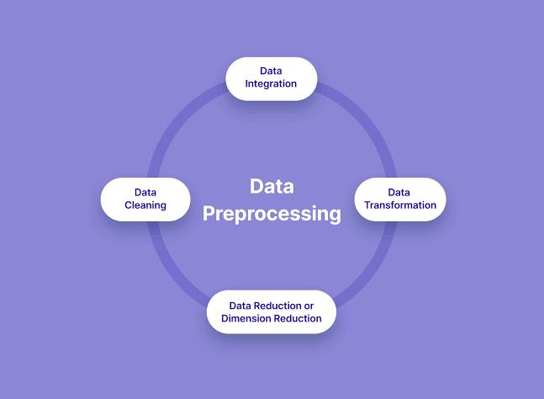

Figure 3.2. Data preprocessing cycle (source: Baheti, 2021)

3.4.1 Data Cleaning

This is cleaning data by fixing or removing incorrect, corrupted, incorrectly formatted, duplicated, and incomplete data within a dataset. The methods used in data cleaning include:
Identify data discrepancies using data observability tools.
Remove unnecessary values.
Remove duplicate data.
Fix structural errors.
Address any missing values.
Standardize data entry and formatting.
Validate and correct values against a known list of entities.
Develop a data quantity strategy.

3.4.2 Data Integration
This process involves aggregating data from various sources and transforming it into a cohesive and consistent format, as data is collected from multiple origins; by this means, data integration becomes a vital part of the process. Combining data sources can lead to more accurate predictions by providing a bigger view of the underlying relationship within the data. It involves extracting, transforming, and loading (ETL) data from various sources to create a coherent and consistent dataset that can be used for analysis, reporting, and decision-making.
The key steps in data integration are
Data Extraction: This is a step in data integration where data is collected from multiple sources, including databases, flat files, and other data repositories.
Data Transformation: Once data has been extracted, it needs to be transformed to fit the system's requirement
Data Loading: After transforming the data, it is loaded into a target system, which is done in batches.
Quality Assurance and Data Governance: This ensures the data integration process complies with the Organization's policies and regulations.
Data Synchronization and Replication: Data integration involves syncing and replicating data between systems to ensure consistency and availability.
Monitoring and Maintenance: This ensures an effective performance ongoing in the data integration process.

3.4.3 Data Reduction

This is a data preprocessing method of reducing the size of the original data so that it can be represented in a smaller size to preserve the integrity of the data (Varma et al., 2023). There are several techniques for data reduction, which may include Data sampling, Data compression, Data Discretization, Dimensionality Reduction, etc.

3.4.4 Data Transformation

This is the process of converting raw data into a format that is more suitable for modelling and analysis. This is a crucial step in data preprocessing; it includes techniques like:
Formatting dates, currencies, and units.
Encoding categorical features.
Creating new features from existing ones.
Handling missing values (imputation or deletion).
Aggregating data points.

3.5 Feature Engineering
Feature engineering is the process of selecting, manipulating, and transforming raw data into features that can be used in creating accurate machine-learning algorithms.
It comprises five stages: feature creation, feature transformation, feature extraction, exploratory data analysis, and benchmarking.
Feature Creation: This step involves generating new features from the existing data. This technique includes combining existing features, creating interaction terms or applying domain knowledge to derive new features that may be more predictive models.
Feature transformation: Transformation involves modifying features to make them more suitable for the model's performance. These include scaling, normalization, and logarithmic transformation.
Feature Extraction: This involves deriving new data features from raw data.The aim of this process is to automatically condense the data volume into a more manageable subset for modeling. Techniques involved in this include Principal Component Analysis (PCA), cluster analysis, text analysis, and edge detection algorithms.
Exploratory Data Analysis: This step is utilized to identify and summarize the key characteristics of a dataset through various data analysis techniques.

Benchmarking: This is a systematic evaluation and comparison of the performance of different techniques to determine their effectiveness in improving the model's performance.

3.6 Confusion Metrics
Quantitative measures are used to assess the performance of a model or system. It provides insights into how well the model is performing and helps in comparing different models or algorithms. It is a table with four different combinations of predicted and actual values, as shown in Figure 3.3 below.
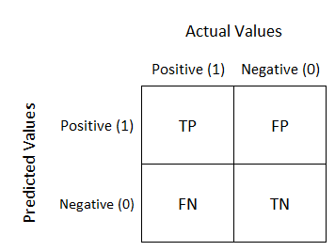

Figure 3.3: Confusion Matrix( Source: Narkhede,2018)

Where,
True Positive (TP) means correctly predicting a positive event,

True Negative (TN) means correctly predicting a negative event,

False Positive (FP) means predicting a positive event, but it is false. It is also called a "TYPE 1 ERROR",

False Negative (FN) means predicting a negative event, but it is false.

B: The predicted events are called "positive" and "Negative", while the actual values are "True" and "False".

A confusion matrix is a table that is used to evaluate performance in a classification algorithm.

3.7 Performance Metric
i. Precision: This measures the proportion of positive predictions that are actually correct.It is determined by dividing the number of true positives by the total of true positives and false positives.
$P=\frac{TP}{TP+FP}$

ii. Accuracy: This is the overall proportion of correct prediction made by the model. It is determined by dividing the number of correctly classified instances by the total number of instances (TN, TP, FN, FP)
$$A=\frac{TP+TN}{Instance}$$

iii. Recall: It measures the proportion of actual positive cases that are correctly identified by the model. It is calculated by dividing the number of true positives by the sum of true positives and false negatives.
$$Recall=\frac{TP}{TP+FN}$$

iv F1- Score: It is the harmonic mean of precision and recall, providing a single metric to balance both of them.
$$F1=2∗\frac{Precision∗Recall}{Precision+Recall}$$

CHAPTER FOUR

SYSTEM IMPLEMENTATION AND RESULT DISCUSSION

4.0 Introduction
This chapter presents the processes and a detailed explanation of the programming language, tools and libraries that were implemented in this project. It also discusses the implementation and the results of the different predictive models that were used to predict, compare and determine which model is best for detecting Fraud in healthcare insurance based on the results gathered from each model.

4.1 Software Requirement
This is the process of executing a plan for software development, which includes the tools, libraries and programming language used for fraud detection shown in Table 4.1

Table 4.1: Summary of Tools, Libraries and Programming Environment Used
Programming Language | Libraries | Programming Environment
Python | Pandas, Numpy, Matplotlib, Seaborn, sklearn, Lazy predict | Google Colab

4.1.1 Libraries

The different libraries that were implemented for fraud detection in this project are shown in Figure 4.1
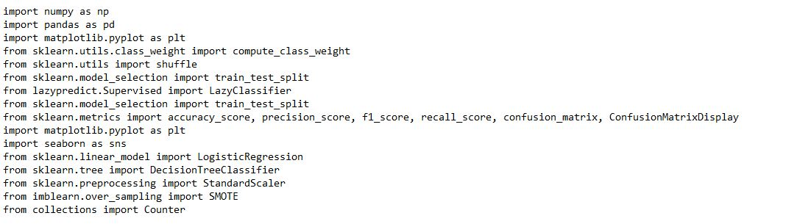

Figure 4.1 Libraries implemented in this Dataset

4.2 Exploratory Data Analysis
This includes analyzing the different categories of the dataset to gain insight into each of the attributes of the dataset.

4.2.1 Dataset Preprocessing and Analysis
This section involves importing the dataset into a data frame and displaying its contents. In the first step, we used one of the libraries, which is Panda, where the file reads from a specific file path that was saved as a CSV file for easy accessibility, as shown in Figure 4.2.
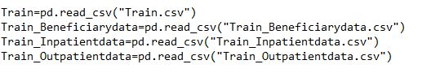

Figure 4.2 The file saved in a specific file path

The data frame serves as a two-dimensional, tabular data structure with labelled rows and columns for data manipulation and analysis. Figure 4.3 provides the code that was used to call the action for generating the total number of rows and columns we have in our dataset, The Five(5) providers and the first five rows of the dataset.
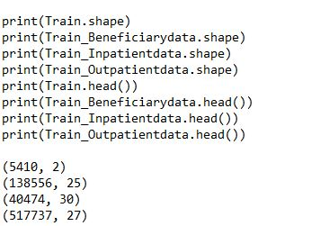
The rows and columns for each of our dataset
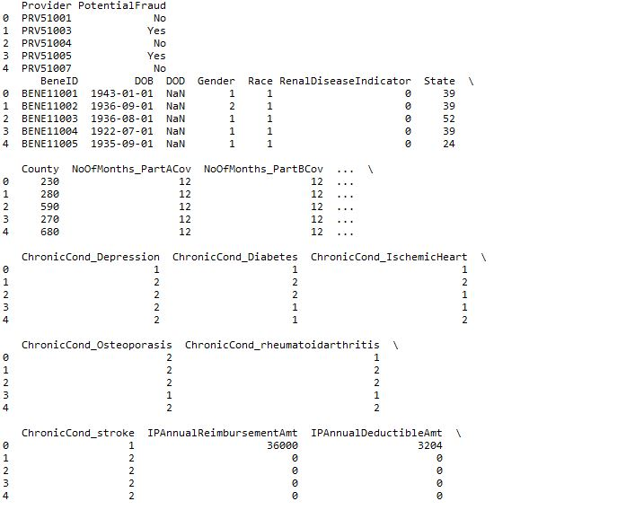

Figure 4.3 Description of the Dataset Head

We proceeded to write a code to merge the inpatient file and the outpatient files into a file called the patient data and then further merged it with the trained data and the beneficiary data, as shown in Figure 4.4
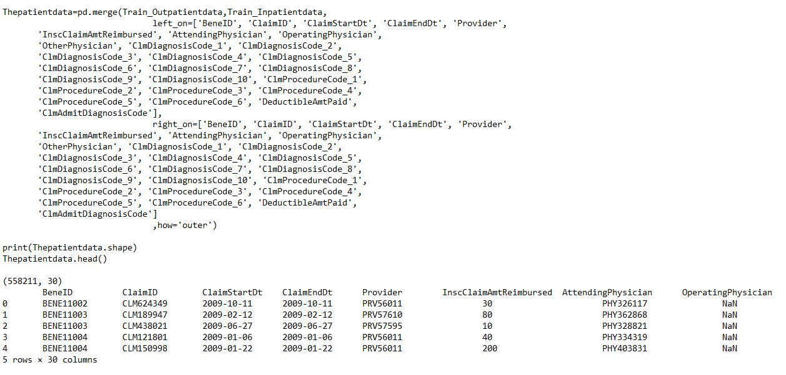
Merging inpatient files and outpatient file
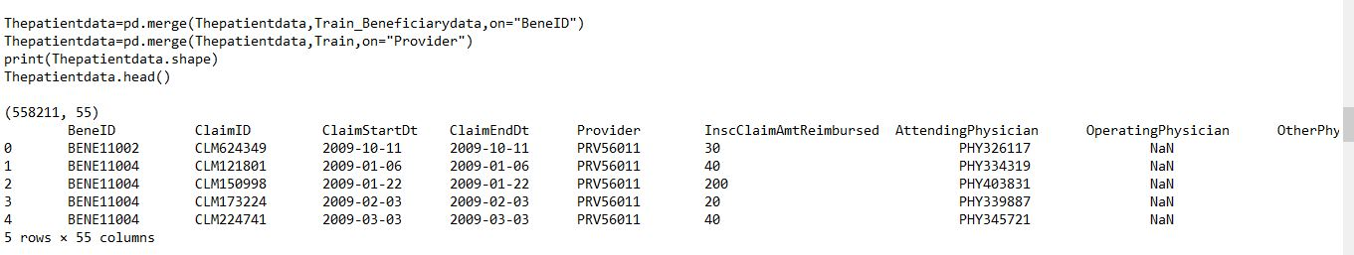

Figure 4.4 Merging patient data, beneficiary data and train data

4.3 Data cleaning
We proceeded to filter out the dataset and check for inconsistent data using the function ".isnull()" and then ran a code to generate a new filtered dataset. According to the result, the code generated a "False" for the cell which was empty and had missing values and "True" for the cell which is not empty and had their values in Figure 4.5
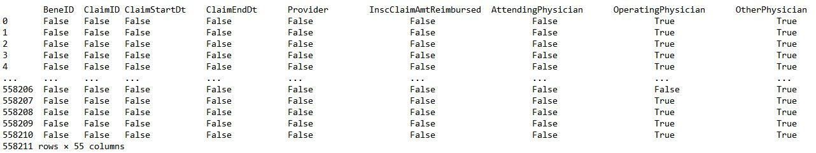

Figure 4.5 Data cleaning has been implemented.

Data Handling
We changed some of the feature values that were mostly in text into numeric values for the machine to easily understand
Potential Fraud had "Yes" or "No" Replace "Yes " with 1 and "No" with 0
Renal Disease Indicator had "y" and "0" Replace "y" with 1 and 0
Chronic Cond has 2 and 1, replacing with 0 and 1

4.4 Feature Engineering
To boost the performance of the model, feature engineering was implemented first by showing the code to generate the number of times the physicians, other physicians and operating Physician attended to all patients shown in Figure 4.6
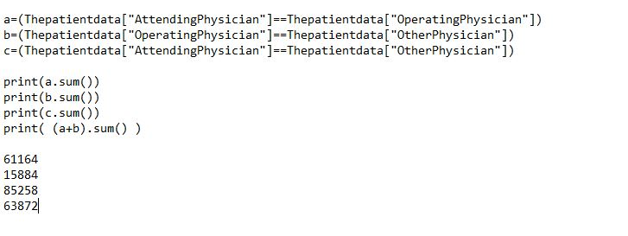

Figure 4.6 Attending Physician attending to patients
The number of days patients made a claim ( claim StartDt- claim EndDt)

Figure 4.7 shows the final.

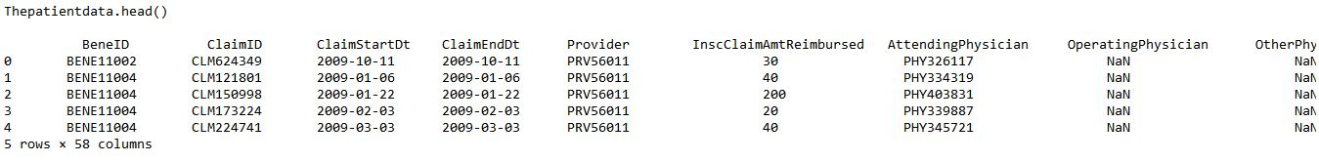Figure 4.7: Final Dataset with 58 columns

4.5 Handling Class Imbalance

This section illustrated the data in a visual context to make it easier to pull an insight Figure 4.8. applied the SMOTE Technique (Synthetic Minority Oversampling Technique), which was a method used to fix imbalances in the dataset. We applied the SMOTE technique to the dataset because there was a significant difference between the range of fraud and non-fraud, and because of the imbalance, the model will not train properly.
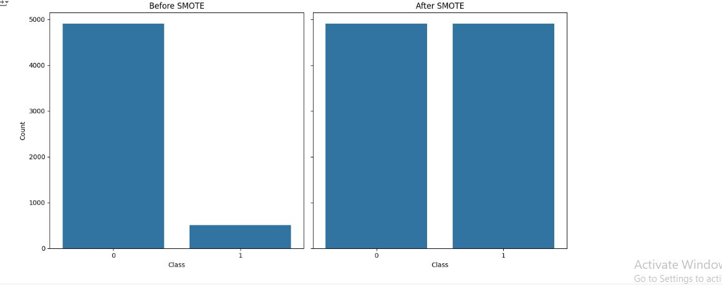

Figure 4.8: Applying SMOTE Technique

4.6 Algorithm Implementation

This section focuses on the algorithms used in this project and prepares the dataset to be used to train and test those algorithms, which are Decision Tree, Logistic Regression, Random Forest Classifier, and AdaBoost Algorithm.

4.6.1 Decision Tree Classifier
After applying the SMOTE Technique to balance the dataset, we needed to find the algorithms with the best parameters.
Decision Tree classifier is a machine learning technique that breaks down datasets into smaller and smaller subsets based on different features, resulting in a tree-like structure of decisions.we generated a code for training the decision tree classifier model. This is shown below in Figure 4.9
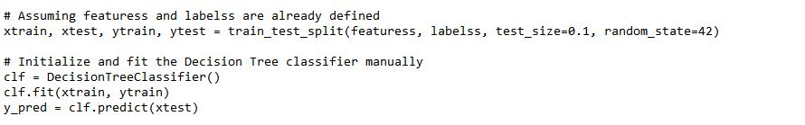

Figure 4.9: Splitting the dataset and training the Decision Tree Classifier

After training, the model was then tested for accuracy and performance. The metrics used to evaluate the model were accuracy, recall, precision, and f1 score..
, as shown in Figure 4.10
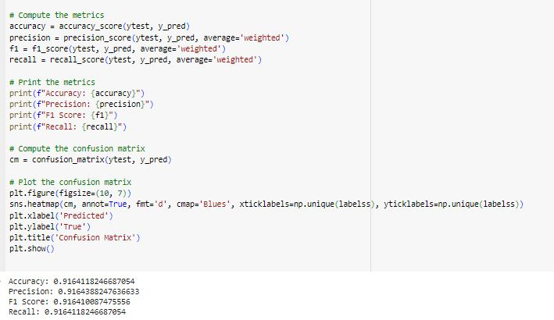

Figure 4.10: Evaluation of the Decision Tree Classifier Model

4.6.2 Logistic Regression Model
Logistic Regression is a machine learning technique that measures the relationship between dependent variables and independent variables by estimating probabilities using logistic functions.we generated code for training the dataset with the logistic regression model, as shown in Figure 4.11 below.
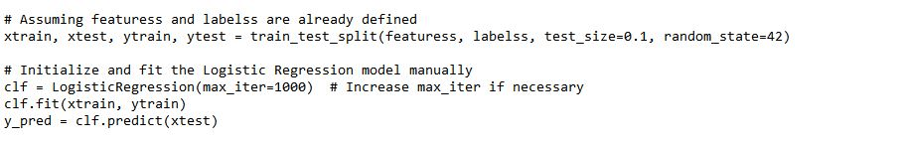

Figure 4.11: Splitting and Training the Logistic Regression Model

After training, the model was then tested for accuracy and performance. The metrics used to evaluate the model were accuracy, recall, precision, and f1 score, as shown in Figure 4.12
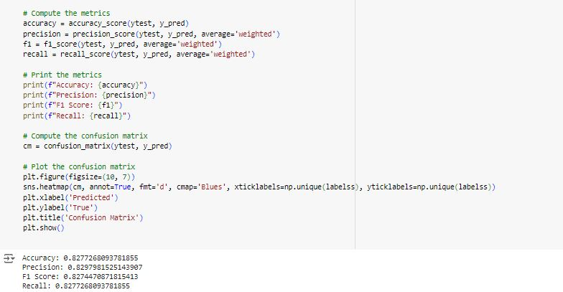

Figure 4.12: Evaluation of Logistic Regression Model

4.6.3 Random Forest Model
Random Forest classifier is a ensemble learning method that constructs multiple decision trees during training and outputs the average prediction of the individual trees.we generated a code for training the dataset with the Random forest model, as shown in Figure 4.13
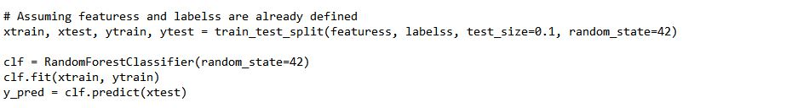

Figure 4.13: Splitting and Training the Random Forest Model

After training, the model was then tested for accuracy and performance. The metrics used to evaluate the model were accuracy, recall, precision, and f1 score.

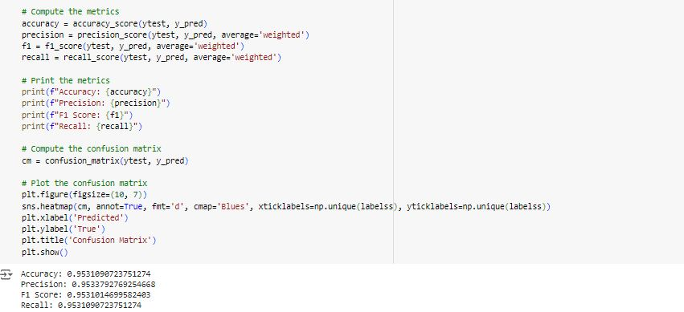

Figure 4.14: Evaluation of Radom Forest Model

4.6.4 AdaBoost Model
AdaBoost is a short form for Adaptive Boosting which is a sequential process that involves training a weak model on a dataset,building subsequent models based on the errors of the previous ones and iterating them until a highly accurate classifier is achieved.we ran a code for training the dataset with the Ada boost model, as shown in Figure 4.15
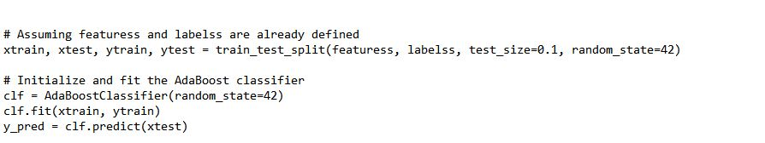

Figure 4.15: Splitting and Training the AdaBoost Model
After training, the model was then tested for accuracy and performance. The metrics used to evaluate the model were accuracy, recall, precision, and f1 score, as shown in Figure 4.16
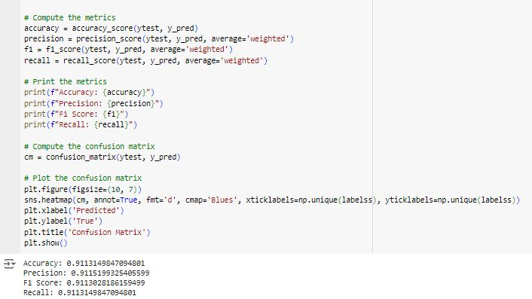

Figure 4.16: Evaluation of AdaBoost Model

4.7 System Evaluation

An overview of the testing and comparative results for the two models are given in this section.

4.7.1 Evaluation of Decision Tree Classifier

The result of the decision tree classifier gave an accuracy of 92%, a precision score of 91.64%, an f1-score of 91% and a recall score of 91%. This is summarized below in Table 4.2

Table 4.2: Summary of the results of the Decision tree classifier
Evaluation Metric | Score
Accuracy | 92%
Precision | 91.64%
F1-Score | 91%
Recall Score | 91%

The table above indicates that the model returned many results, and most of the labels were correctly predicted. Figure 4.17 below shows the confusion matrix of the Decision Tree Classifier Model.
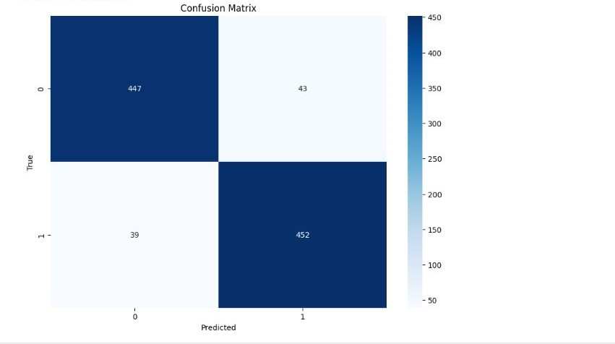

Figure 4.17: Confusion Matrix of Decision Tree classifier model

4.7.2 Evaluation of Logistic Regression Model

The result of the decision tree classifier gave an accuracy of 83%, a precision score of 82.97%, an f1-score of 82.74% and a recall score of 82.80%. This is summarized below in Table 4.3

Table 4.3: Summary of the result of the logistic regression model
Evaluation Metrics | Score
Accuracy | 83%
Precision | 82.74%
F1-Score | 82.74%
Recall | 82.80%

The logistic regression model's confusion matrix is shown below in Figure 4.18
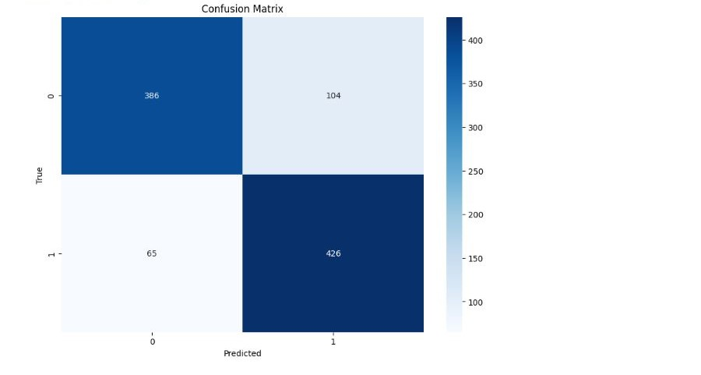

Figure 4.18: Confusion Matrix of the Logistic Regression Model

4.7.3 Evaluation of Random Forest Model

The result of the Random Forest classifier gave an accuracy of 95.3%, a precision score of 95%, an f1-score of 95% and a recall score of 95.31%. This is summarized below in Table 4.4

Table 4.4: Summary of the result of the random forest model
Evaluation Metrics | Score
Accuracy | 95.3%
Precision | 95%
F1-Score | 95%
Recall | 95.31%

The random forest model's confusion matrix is shown below in Figure 4.19

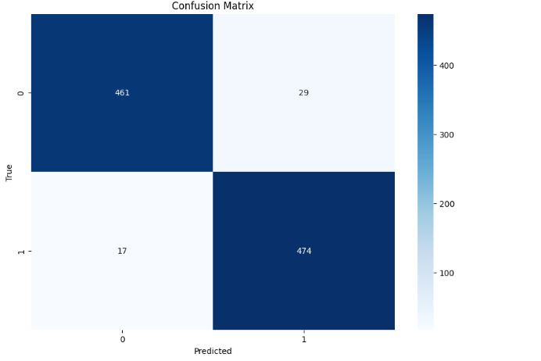

Figure 4.19: Confusion Matrix of the Random Forest model

4.7.4 Evaluation of the Adaboost Model

The result of the Adaboost classifier gave an accuracy of 91.13%, a precision score of 91.12%, an f1-score of 91% and a recall score of 91%. This is summarized below in Table 4.5

Table 4.5: Summary of the result of the Adaboost model
Evaluation Metrics | Score
Accuracy | 91.13%
Precision | 91%
F1-Score | 91.12%
Recall | 91%

The Ada Boost model's confusion matrix is shown below in Figure 4.20
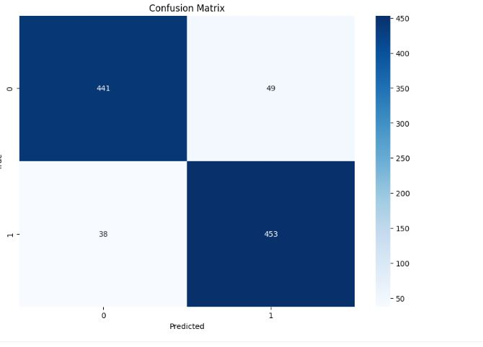

Figure 4.20: Confusion Matrix of the AdaBoost model

4.8 Comparison of the models

The comparison of the four models is shown in Table 4.6

Table 4.6: Comparison of models
 | Evaluation Metrics
 | Accuracy | Precision | F1-score | Recall
Model
Decision Tree Classifier | 92% | 91.64% | 91% | 91%
Logistic Regression | 83% | 82.74% | 82.74% | 82.80%
Random Forest Classifer | 95.3% | 95% | 95% | 95.31%
Ada Boost | 91.13% | 91% | 91.12% | 91%

In comparison to the accuracy scores of all the other models, the Random Forest classifier got the greatest accuracy score of 95.3%. It shows that the Random Forest classifier is a more suitable model for balanced data. This is because the random forest has the ability to capture non-linear and complex relations, reduce overfitting, provide insight into important features, and help identify which variables are most influential in detecting Fraud.

CHAPTER FIVE

SUMMARY, CONCLUSION AND RECOMMENDATION

5.0 Introduction
This chapter provides the summary of this project, its findings and results, the conclusions, the limitations of the project, and recommendations for future research.

5.1 Summary
Fraud in the healthcare insurance system has become a very sensitive issue, and this study focused on fraud detection in healthcare insurance using machine learning algorithms. The machine learning algorithms that were used were the Logistic Regression, AdaBoost algorithm, Decision tree classifier and Random Forest classifier algorithm.

The dataset used was obtained from the Kaggle website, whereby the dataset was into 3(three categories) which were inpatient, outpatient and beneficiary. We used different tools and libraries for the implementation, such as Panda, numpy, matplotlib, seaborn, sklearn, lazypredicit, and Python. We further split the dataset into training and testing data after the dataset had been preprocessed and cleaned.
After training the models, the models were tested for performance evaluation, and the results were as follows: The result of the decision tree classifier gave an accuracy of 92%, a precision score of 91.64%, an f1-score of 91% and a recall score of 91%, The result of the Adaboost classifier gave an accuracy of 91.13%, a precision score of 91.12%, an f1-score of 91% and a recall score of 91%, The result of the decision tree classifier gave an accuracy of 83%, a precision score of 82.97%, an f1-score of 82.74% and a recall score of 82.80% and The result of the Random Forest classifier gave an accuracy of 95.3%, a precision score of 95%, an f1-score of 95% and a recall score of 95.31%. The outcome demonstrated that the random forest classifier was the best model for identifying fraud since it had a greater effect than the decision tree classifier and better performance metrics overall.

5.2 Conclusion
Fraud in the healthcare insurance system is a very sensitive issue, and the main focus of this project lies in the detection of fraudulent claims in healthcare insurance and in helping reduce the number of victims of fraud.

5.3 Limitations
The quality and comprehensiveness of the data could significantly affect the model's performance because the dataset might not have fully represented a real-world healthcare fraud scenario due to security and privacy and the high level of the unbalanced dataset.

5.4 Recommendations and Future Works
The models from this work recommend future research and practical application in fraud detection should be carried out in healthcare industries, and certain models, such as Support Vector Machine(SVM), could demonstrate a superior level of accuracy in identifying fraudulent claims compared to the other models.

REFERENCES

Agarwal, S. (2023). An intelligent machine learning approach for fraud detection in medical claim Insurance: A comprehensive study. Sch J Eng Tech,2023 Sep 11(9):191-200

Bauder, R.A. & Khoshgoftaar, T.M. (2018). "The Detection of Medicare Fraud Using Machine Learning Methods with Excluded Provider Labels,” The Thirty-First International Florida Artificial Intelligence Research Society Conference, pp. 404-409.

Baheti,P.(2021).A simple guide to data preprocessing in machine learning.V7 Labs, London.

Breiman, L., &Adele, C.(2001)."Random Forests".Machine Learning 45, pp. 5–32.

Chen, Z. X., Lindsey, H., Bidur, B., Zhao, Y., Kavon, D., &Salisa C.W. (2020). Recommendations to protect patients and health care practices from Medicare and Medicaid fraud. Journal of the American Pharmacists Association 60: e60–e65. [CrossRef] [PubMed] .

Citko, W., & Sienko, W. (2022). Inpainted Image Reconstruction Using an Extended Hopfield Neural Network Based Machine Learning System. Sensors, 22(3), 813.

Daciuk, T., & Jou, S. (2010). An introduction to data mining and predictive analytics. https://doi.org/10.1145/1923947.1923983
Dash,S., Shakyawar, K.S., Sharma, K.& Kaushik,S.(2019). Big Data in healthcare:Management,analysis and future prospects.Journal of big data 6 (1), 1-25

Debener,J., Heinke,V.& Kriebel,J.(2023). Detecting Insurance Fraud using supervised and unsupervised machine learning.Journal of Risk and Insurance,90(3),743- 768.

Goodfellow, I., Bengio, Y., &Courville, A.(2016).Deep Learning (adaptive computation &machine learning services).MIT Press.

Gureent,K.(2023). Power of Artificial Neural Networks: A comprehensive guide.

He,K., Zhang,X., Ren,S.,&Sun,J.(2016). Deep residual learning for image recognition.In Proceedings of the IEEE conference on computer vision and pattern recognition(pp 726-734).

Johnson, M.,E & Nagarur, N.(2015). Multistage methodology to detect health insurance claim fraud. Health care Management science 19, 249-260

Lavanya,S., Kumar,M.S.& Kumar,M.P.(2021). Machine learning based approaches for healthcare fraud detection: A comparative analysis.Annals of the Romanian society for cell biology, 8644-8654.

Laiqa.R., Waqas,H.B., Nisar,K. & Nisar,S.(2022). Prediction of insurance fraud detection using machine learning algorithm: Mehran University Research Journal of Engineering and Technology 41(1),33-40.

Liang, J., Zheng, X., Chen, Z., Dai, S., Xu, J., Ye, H., ... & Lei, J. (2019). The experience and challenges of healthcare-reform-driven medical consortia and Regional Health Information Technologies in China: a longitudinal study. International journal of medical informatics, 131, 103954.

Liu, J. L., Maniadakis, N.,Gray, A.,&Rayner, M.(2002).The economic burden of coronary heart disease in the UK.Heart,88(6),597-603.

Ma, F., You, Q., Xiao, H., Chitta, R., Zhou, J., & Gao, J.(2018). Kame) Knowledge- based attention model for diagnosis prediction in healthcare.In Proceedings of the 27th ACM International Conference on Information and Knowledge Management(pp. 742–752).

Mackey, T. K., Miyachi, K., Fung, D., Qian, S., & Short, J. (2020). Combating health care fraud and abuse: Conceptualization and prototyping study of a block chain anti-fraud framework. Journal of medical Internet research, 22(9), e18623.

Nabrawi,E. & Alanazi,A.(2023). Fraud detection in healthcare insurance claims using machine learning.Risk 11(9),160,2023.

Naga, P.J., Venkata,R.& Suresh,S.(2023). Comparative analysis for identifying the fraudulent healthcare claims. Grenze international Journal of Engineering and Technology,June Issue.

Nalluri,V., Chang,J.R,Chen,L.S.,& Chen, J.C.(2023). Building Prediction Models and Discovering Important Factors of Health Insurance Fraud Using Machine Learning Method.Journal of Ambient Intelligence and Humanized Computing 14(7),9607-9619.

Narkhede,S.(2018). Understanding Confusion Matrix.Retrieved July 12,2022, from Towardsdatascience:https://towardsdatascience.com/understanding-confusion- matrix-a9ad42dcfd62

Ngai, E. W., Hu, Y., Wong, Y. H., Chen, Y.,& Sun, X.(2011). The application of data mining techniques in financial fraud detection: A classification framework and an academic review of literature.Decision support systems,50(3),559-569.

NHCAA. (2018). The Problem of Health Care Fraud: A Serious and Costly Reality for All Americans. National Health Care Anti-Fraud Association (NHCAA). Available online: http://www.nhcaa.org/resources/health-care-anti-fraud resources/the-challenge-of -health-care-fraud/ (accessed on 8 October 2021).

Nicholas, L.H., Caroline,H., Jodi,B.S.,& Matthew, D.E. (2020). Association between Treatment by Fraud and Abuse Perpetrators and Health Outcomes among Medicare Beneficiaries. JAMA Internal Medicine 180: 62–69.

Saba,K., Ahmad,R.B.& Sarlan,A.B.(2017). Framework for identification of fraudulent health insurance claims using association rule mining. IEEE Conference on Big Data and Analytics(ICBDA),99-104.

Schapire,R.E.(2013). Explaining AdaBoost.Empiricial inference: festschrift in honor of vladimirn.vapnik,37-52.

Tanwar, S., Parekh, K., & Evans, R. (2020). Block chain-based electronic healthcare record system for healthcare 4.0 applications. Journal of Information Security and Applications, 50, 102407.
Thaifur, Andi Yaumil Bay R., M. Alimin, M., Andi,I.S., &Amran, R.(2021). How to detect healthcare fraud? “A systematic review”. Gaceta Sanitaria 35: S441–49. [CrossRef] [PubMed].
Veena,K., Supriya, S., Deepa,D.,Cruz,J.A.,Dheepan,GM.K.& Ayila,D.(2023). Predicting health insurance claim frauds using supervised machine learning techniques.Eighth International Conference on Science Technology Engineering and Mathematics(ICONSTEM),1-7,2023.

APPENDIX

import numpy as np
import pandas as pd
import matplotlib.pyplot as plt
from sklearn.utils.class_weight import compute_class_weight
from sklearn.utils import shuffle
from sklearn.model_selection import train_test_split
from lazypredict.Supervised import LazyClassifier
from sklearn.model_selection import train_test_split
from sklearn.metrics import accuracy_score, precision_score, f1_score, recall_score, confusion_matrix, ConfusionMatrixDisplay
import matplotlib.pyplot as plt
import seaborn as sns
from sklearn.linear_model import LogisticRegression
from sklearn.tree import DecisionTreeClassifier
from sklearn.preprocessing import StandardScaler
from imblearn.over_sampling import SMOTE
from collections import Counter
from sklearn.ensemble import AdaBoostClassifier

Train=pd.read_csv("Train.csv")
Train_Beneficiarydata=pd.read_csv("Train_Beneficiarydata.csv")
Train_Inpatientdata=pd.read_csv("Train_Inpatientdata.csv")
Train_Outpatientdata=pd.read_csv("Train_Outpatientdata.csv")

print(Train.shape)
print(Train_Beneficiarydata.shape)
print(Train_Inpatientdata.shape)
print(Train_Outpatientdata.shape)
print(Train.head())
print(Train_Beneficiarydata.head())
print(Train_Inpatientdata.head())
print(Train_Outpatientdata.head())

Thepatientdata=pd.merge(Train_Outpatientdata,Train_Inpatientdata,
left_on=['BeneID', 'ClaimID', 'ClaimStartDt', 'ClaimEndDt', 'Provider',
'InscClaimAmtReimbursed', 'AttendingPhysician', 'OperatingPhysician',
'OtherPhysician', 'ClmDiagnosisCode_1', 'ClmDiagnosisCode_2',
'ClmDiagnosisCode_3', 'ClmDiagnosisCode_4', 'ClmDiagnosisCode_5',
'ClmDiagnosisCode_6', 'ClmDiagnosisCode_7', 'ClmDiagnosisCode_8',
'ClmDiagnosisCode_9', 'ClmDiagnosisCode_10', 'ClmProcedureCode_1',
'ClmProcedureCode_2', 'ClmProcedureCode_3', 'ClmProcedureCode_4',
'ClmProcedureCode_5', 'ClmProcedureCode_6', 'DeductibleAmtPaid',
'ClmAdmitDiagnosisCode'],
right_on=['BeneID', 'ClaimID', 'ClaimStartDt', 'ClaimEndDt', 'Provider',
'InscClaimAmtReimbursed', 'AttendingPhysician', 'OperatingPhysician',
'OtherPhysician', 'ClmDiagnosisCode_1', 'ClmDiagnosisCode_2',
'ClmDiagnosisCode_3', 'ClmDiagnosisCode_4', 'ClmDiagnosisCode_5',
'ClmDiagnosisCode_6', 'ClmDiagnosisCode_7', 'ClmDiagnosisCode_8',
'ClmDiagnosisCode_9', 'ClmDiagnosisCode_10', 'ClmProcedureCode_1',
'ClmProcedureCode_2', 'ClmProcedureCode_3', 'ClmProcedureCode_4',
'ClmProcedureCode_5', 'ClmProcedureCode_6', 'DeductibleAmtPaid',
'ClmAdmitDiagnosisCode']
,how='outer')

print(Thepatientdata.shape)
Thepatientdata.head()

BeneID ClaimID ClaimStartDt ClaimEndDt Provider InscClaimAmtReimbursed AttendingPhysician OperatingPhysician OtherPhysician ClmDiagnosisCode_1 ... ClmProcedureCode_2 ClmProcedureCode_3 ClmProcedureCode_4 ClmProcedureCode_5 ClmProcedureCode_6 DeductibleAmtPaid ClmAdmitDiagnosisCode AdmissionDt DischargeDt DiagnosisGroupCode

Thepatientdata=pd.merge(Thepatientdata,Train_Beneficiarydata,on="BeneID")
Thepatientdata=pd.merge(Thepatientdata,Train,on="Provider")
print(Thepatientdata.shape)
Thepatientdata.head()

BeneID ClaimID ClaimStartDt ClaimEndDt Provider InscClaimAmtReimbursed AttendingPhysician OperatingPhysician OtherPhysician ClmDiagnosisCode_1 ... ChronicCond_Diabetes ChronicCond_IschemicHeart ChronicCond_Osteoporasis ChronicCond_rheumatoidarthritis ChronicCond_stroke IPAnnualReimbursementAmt IPAnnualDeductibleAmt OPAnnualReimbursementAmt OPAnnualDeductibleAmt PotentialFraud

Thepatientdata.info()

<class 'pandas.core.frame.DataFrame'>
RangeIndex: 558211 entries, 0 to 558210
Data columns (total 55 columns):
# Column Non-Null Count Dtype
--- ------ -------------- -----
0 BeneID 558211 non-null object
1 ClaimID 558211 non-null object
2 ClaimStartDt 558211 non-null object
3 ClaimEndDt 558211 non-null object
4 Provider 558211 non-null object
5 InscClaimAmtReimbursed 558211 non-null int64
6 AttendingPhysician 556703 non-null object
7 OperatingPhysician 114447 non-null object
8 OtherPhysician 199736 non-null object
9 ClmDiagnosisCode_1 547758 non-null object
10 ClmDiagnosisCode_2 362605 non-null object
11 ClmDiagnosisCode_3 243055 non-null object
12 ClmDiagnosisCode_4 164536 non-null object
13 ClmDiagnosisCode_5 111924 non-null object
14 ClmDiagnosisCode_6 84392 non-null object
15 ClmDiagnosisCode_7 66177 non-null object
16 ClmDiagnosisCode_8 53444 non-null object
17 ClmDiagnosisCode_9 41815 non-null object
18 ClmDiagnosisCode_10 5010 non-null object
19 ClmProcedureCode_1 23310 non-null float64
20 ClmProcedureCode_2 5490 non-null float64
21 ClmProcedureCode_3 969 non-null float64
22 ClmProcedureCode_4 118 non-null float64
23 ClmProcedureCode_5 9 non-null float64
24 ClmProcedureCode_6 0 non-null float64
25 DeductibleAmtPaid 557312 non-null float64
26 ClmAdmitDiagnosisCode 145899 non-null object
27 AdmissionDt 40474 non-null object
28 DischargeDt 40474 non-null object
29 DiagnosisGroupCode 40474 non-null object
30 DOB 558211 non-null object
31 DOD 4131 non-null object
32 Gender 558211 non-null int64
33 Race 558211 non-null int64
34 RenalDiseaseIndicator 558211 non-null object
35 State 558211 non-null int64
36 County 558211 non-null int64
37 NoOfMonths_PartACov 558211 non-null int64
38 NoOfMonths_PartBCov 558211 non-null int64
39 ChronicCond_Alzheimer 558211 non-null int64
40 ChronicCond_Heartfailure 558211 non-null int64
41 ChronicCond_KidneyDisease 558211 non-null int64
42 ChronicCond_Cancer 558211 non-null int64
43 ChronicCond_ObstrPulmonary 558211 non-null int64
44 ChronicCond_Depression 558211 non-null int64
45 ChronicCond_Diabetes 558211 non-null int64
46 ChronicCond_IschemicHeart 558211 non-null int64
47 ChronicCond_Osteoporasis 558211 non-null int64
48 ChronicCond_rheumatoidarthritis 558211 non-null int64
49 ChronicCond_stroke 558211 non-null int64
50 IPAnnualReimbursementAmt 558211 non-null int64
51 IPAnnualDeductibleAmt 558211 non-null int64
52 OPAnnualReimbursementAmt 558211 non-null int64
53 OPAnnualDeductibleAmt 558211 non-null int64
54 PotentialFraud 558211 non-null object
dtypes: float64(7), int64(22), object(26)
memory usage: 234.2+ MB

Thepatientdata.isnull()
a=(Thepatientdata["AttendingPhysician"]==Thepatientdata["OperatingPhysician"])
b=(Thepatientdata["OperatingPhysician"]==Thepatientdata["OtherPhysician"])
c=(Thepatientdata["AttendingPhysician"]==Thepatientdata["OtherPhysician"])

print(a.sum())
print(b.sum())
print(c.sum())
print( (a+b).sum() )

def physician_same(row):
atten_oper=row["AttendingPhysician"]==row["OperatingPhysician"]
oper_other=row["OperatingPhysician"]==row["OtherPhysician"]
atten_other=row["AttendingPhysician"]==row["OtherPhysician"]
if atten_oper==True and oper_other==True:# atten = oper = other
return 0
elif atten_oper==True and oper_other==False:# atten = oper != other
return 1
elif atten_oper==False and oper_other==True:# atten != oper = other
return 2
else:# atten != oper != other
return 3

phy_same=Thepatientdata.apply(physician_same,axis=1)
Thepatientdata["phy_same"]=phy_same

def physician_count(row,list_count):
count=0
for col in list_count:
if pd.isnull(row[col]):
continue
else:
count+=1
return count

list_count=["AttendingPhysician","OperatingPhysician","OtherPhysician"]
phy_count=Thepatientdata.apply(physician_count,axis=1,args=(list_count,))
Thepatientdata["phy_count"]=phy_count

startdate= pd.to_datetime( Thepatientdata["ClaimStartDt"] )
enddate= pd.to_datetime( Thepatientdata["ClaimEndDt"] )

period = ( enddate - startdate).dt.days
Thepatientdata["period"] = period

Thepatientdata.head()

copy = Thepatientdata.copy()

cronic_cols_names=copy.columns[ copy.columns.str.startswith("ChronicCond") ]
cronic_cols=copy[ cronic_cols_names ]
cronic=cronic_cols.replace({2:0})
copy[ cronic_cols_names ]=cronic

copy["PotentialFraud"]=copy["PotentialFraud"].replace({"Yes":1,"No":0})
copy["Gender"]=copy["Gender"].replace({2:0})
startadmt= pd.to_datetime( copy["AdmissionDt"] )
enddatadmt= pd.to_datetime( copy["DischargeDt"] )

periodadmt = ( enddatadmt - startadmt).dt.days
copy["periodadmt"] = periodadmt
copy["periodadmt"]=copy["periodadmt"].fillna(0)

copy["RenalDiseaseIndicator"]=copy["RenalDiseaseIndicator"].replace({"Y":1})

birthdate=pd.to_datetime(copy["DOB"])
enddate=pd.to_datetime(copy["DOD"])

# cheack whether the patient dead or alife
def alife_function(value):
if value==True:
return 1
else:
return 0
alife = pd.isna(enddate).apply(alife_function)

# get the age of patient
max_date=enddate.dropna().max()
enddate[pd.isna(enddate)]=max_date
period=(((enddate-birthdate).dt.days/356).astype(int))

copy["age"]=period
copy["alife"]=alife

copy.head()
def groupby(df,by,vars_to_group,methods,col_ident,as_index=True,agg=False):
if agg:
grouped=df.groupby(by=by,as_index=as_index)[vars_to_group].agg(methods)
cols=['_'.join(col) for col in grouped.columns.values]
cols=[col_ident+"_"+col for col in cols]
grouped.columns=cols
return grouped

else:
concat=df.groupby(by=by,as_index=as_index)[vars_to_group].transform(methods[0])
cols=[ col_ident+"_"+col+"_"+methods[0] for col in concat.columns ]
concat.columns=cols

for method in methods[1:]:
grouped=df.groupby(by=by,as_index=as_index)[vars_to_group].transform(method)
cols=[col_ident+"_"+col+"_"+method for col in grouped.columns]
grouped.columns=cols
concat=pd.concat([concat,grouped],axis=1)

return concat

money_cols=["InscClaimAmtReimbursed","DeductibleAmtPaid","NoOfMonths_PartACov","NoOfMonths_PartBCov",
"IPAnnualReimbursementAmt","IPAnnualDeductibleAmt","OPAnnualReimbursementAmt","OPAnnualDeductibleAmt"]

provider_money=groupby(copy,["Provider"],money_cols,["mean","std"],"provider",
True,False)

banel_money=groupby(copy,["BeneID"],money_cols,["mean","std"],"banel",
True,False)

diag1_money=groupby(copy,["ClmDiagnosisCode_1"],money_cols,["mean","std"],"diag1",
True,False)

selected_cols_names=["phy_same","phy_count","period","periodadmt","age","alife","Provider","PotentialFraud"]
selected_cols=copy[selected_cols_names]

data=pd.concat([selected_cols,provider_money,banel_money,diag1_money],axis=1)

grouped=data.groupby(by=["Provider","PotentialFraud"]).agg("mean").reset_index()

grouped.head()

grouped=grouped.fillna(0)

# Assuming 'grouped' DataFrame is already defined and filled
grouped = grouped.fillna(0)
features = grouped.iloc[:, 2:]
labels = grouped.iloc[:, 1]

# Apply SMOTE
oversample = SMOTE(random_state=42)
features_resampled, labels_resampled = oversample.fit_resample(features, labels)

# Standardize features
scaler = StandardScaler()
features_stand = scaler.fit_transform(features_resampled)

# Distribution before SMOTE
counter_before = Counter(labels)
df_before = pd.DataFrame.from_dict(counter_before, orient='index').reset_index()
df_before.columns = ['Class', 'Count']

# Distribution after SMOTE
counter_after = Counter(labels_resampled)
df_after = pd.DataFrame.from_dict(counter_after, orient='index').reset_index()
df_after.columns = ['Class', 'Count']

# Plotting
fig, axes = plt.subplots(1, 2, figsize=(12, 6), sharey=True)

sns.barplot(x='Class', y='Count', data=df_before, ax=axes[0])
axes[0].set_title('Before SMOTE')
axes[0].set_xlabel('Class')
axes[0].set_ylabel('Count')

sns.barplot(x='Class', y='Count', data=df_after, ax=axes[1])
axes[1].set_title('After SMOTE')
axes[1].set_xlabel('Class')

plt.tight_layout()
plt.show()

# Assuming labels and features_stand are already defined
ff = compute_class_weight(class_weight="balanced", classes=np.unique(labels_resampled), y=labels_resampled)
cw = dict(zip(np.unique(labels_resampled), ff))

featuress, labelss = shuffle(features_stand, labels_resampled, random_state=42)
xtrain, xtest, ytrain, ytest = train_test_split(featuress, labelss, test_size=0.1, random_state=42)
xtrain=xtrain.astype(np.float32)
xtest=xtest.astype(np.float32)
ytrain=ytrain.astype(np.float32).to_numpy()
ytest=ytest.astype(np.float32).to_numpy()

ytrain=ytrain.reshape(ytrain.shape+(1,))
ytest=ytest.reshape(ytest.shape+(1,))

print(xtrain.shape)
print(xtest.shape)
print(ytrain.shape)
print(ytest.shape)

# Assuming featuress and labelss are already defined
xtrain, xtest, ytrain, ytest = train_test_split(featuress, labelss, test_size=0.1, random_state=42)

# Initialize and fit the Logistic Regression model manually
clf = LogisticRegression(max_iter=1000) # Increase max_iter if necessary
clf.fit(xtrain, ytrain)
y_pred = clf.predict(xtest)

# Compute the metrics
accuracy = accuracy_score(ytest, y_pred)
precision = precision_score(ytest, y_pred, average='weighted')
f1 = f1_score(ytest, y_pred, average='weighted')
recall = recall_score(ytest, y_pred, average='weighted')

# Print the metrics
print(f"Accuracy: {accuracy}")
print(f"Precision: {precision}")
print(f"F1 Score: {f1}")
print(f"Recall: {recall}")

# Compute the confusion matrix
cm = confusion_matrix(ytest, y_pred)

# Plot the confusion matrix
plt.figure(figsize=(10, 7))
sns.heatmap(cm, annot=True, fmt='d', cmap='Blues', xticklabels=np.unique(labelss), yticklabels=np.unique(labelss))
plt.xlabel('Predicted')
plt.ylabel('True')
plt.title('Confusion Matrix')
plt.show()

# Assuming featuress and labelss are already defined
xtrain, xtest, ytrain, ytest = train_test_split(featuress, labelss, test_size=0.1, random_state=42)

# Initialize and fit the Decision Tree classifier manually
clf = DecisionTreeClassifier()
clf.fit(xtrain, ytrain)
y_pred = clf.predict(xtest)

# Compute the metrics
accuracy = accuracy_score(ytest, y_pred)
precision = precision_score(ytest, y_pred, average='weighted')
f1 = f1_score(ytest, y_pred, average='weighted')
recall = recall_score(ytest, y_pred, average='weighted')

# Print the metrics
print(f"Accuracy: {accuracy}")
print(f"Precision: {precision}")
print(f"F1 Score: {f1}")
print(f"Recall: {recall}")

# Compute the confusion matrix
cm = confusion_matrix(ytest, y_pred)

# Plot the confusion matrix
plt.figure(figsize=(10, 7))
sns.heatmap(cm, annot=True, fmt='d', cmap='Blues', xticklabels=np.unique(labelss), yticklabels=np.unique(labelss))
plt.xlabel('Predicted')
plt.ylabel('True')
plt.title('Confusion Matrix')
plt.show()

clf = RandomForestClassifier(random_state=42)
clf.fit(xtrain, ytrain)
y_pred = clf.predict(xtest)

# Compute the metrics
accuracy = accuracy_score(ytest, y_pred)
precision = precision_score(ytest, y_pred, average='weighted')
f1 = f1_score(ytest, y_pred, average='weighted')
recall = recall_score(ytest, y_pred, average='weighted')

# Print the metrics
print(f"Accuracy: {accuracy}")
print(f"Precision: {precision}")
print(f"F1 Score: {f1}")
print(f"Recall: {recall}")

# Compute the confusion matrix
cm = confusion_matrix(ytest, y_pred)

# Plot the confusion matrix
plt.figure(figsize=(10, 7))
sns.heatmap(cm, annot=True, fmt='d', cmap='Blues', xticklabels=np.unique(labelss), yticklabels=np.unique(labelss))
plt.xlabel('Predicted')
plt.ylabel('True')
plt.title('Confusion Matrix')
plt.show()

# Initialize and fit the AdaBoost classifier
clf = AdaBoostClassifier(random_state=42)
clf.fit(xtrain, ytrain)
y_pred = clf.predict(xtest)

# Compute the metrics
accuracy = accuracy_score(ytest, y_pred)
precision = precision_score(ytest, y_pred, average='weighted')
f1 = f1_score(ytest, y_pred, average='weighted')
recall = recall_score(ytest, y_pred, average='weighted')

# Print the metrics
print(f"Accuracy: {accuracy}")
print(f"Precision: {precision}")
print(f"F1 Score: {f1}")
print(f"Recall: {recall}")

# Compute the confusion matrix
cm = confusion_matrix(ytest, y_pred)

# Plot the confusion matrix
plt.figure(figsize=(10, 7))
sns.heatmap(cm, annot=True, fmt='d', cmap='Blues', xticklabels=np.unique(labelss), yticklabels=np.unique(labelss))
plt.xlabel('Predicted')
plt.ylabel('True')
plt.title('Confusion Matrix')
plt.show()

